Business Template

Subject areas
Logo / Image

Contents
Business Description 3
1.1 the Benefits of implementing a database. Project Vision 3
2 Model description 3
2.1 Definitions & Acronyms 3
2.2 Logical Scheme 3
2.3 Objects 3

Business Description

the Benefits of implementing a database. Project Vision
To answer these questions, you can rely on the following questions:
- How will the database solve the problems listed in the description?
- How will it ensure data integrity, consistency, and traceability?
- How does your model store the history of changes?
- How does your structure allow the system to scale without major redesign?
- Which constraints and checks have you added to keep data correct as volume grows?

The purpose of the E-commerce Marketplace database is to support an online platform where multiple sellers can suggest products and buyers can browse, purchase, and review them. The database stores structured information about users, products, orders, payments, deliveries, and inventory. By organizing this data into related tables using relational database modeling principles, the database allows the platform to manage marketplace operations efficiently and ensures that information about transactions and users is stored in a consistent and reliable way.

Data consistency and integrity are ensured by using relational database constraints. Each table contains a primary key that uniquely identifies records, while foreign keys enforce relationships between entities such as orders, products, and users. Additional constraints such as NOT NULL, UNIQUE, and CHECK conditions help prevent invalid data from being inserted into the system. For example, rating values are restricted to valid ranges and user emails must be unique.

The database model also maintains the history of important changes. Instead of overwriting existing data, the system records events in dedicated history tables. For example, changes in order status are stored in the order_status_history table, while stock updates are recorded in the inventory_history table. This design ensures full traceability of system activity and allows the platform to analyze historical transactions and inventory changes.

The structure of the database is designed to be scalable. Because the system follows normalization principles and seperates different concepts into independent tables, new features can be added without major changes to the existing schema. For instance, additional functionality such as advanced promotions, product variants, or shipment tracking can integrated easily.

To ensure data correctness as the system grows, several constraints and validation mechanisms are used. These include primary keys, foreign keys, composite keys, unique constraints, and validation checks on certain attributes. Together, these mechanisms ensure that relationships between tables remain consistent and that the database continues to operate reliably as the volume of data increases.

Model description

Definitions & Acronyms
To answer these questions, you can rely on the following questions:
- Which key entities, roles, or processes require formal definitions for correct interpretation of the model?
- Which terms could be misunderstood without clarification?
- Which abbreviations or role names appear repeatedly in tables or relationships?

To ensure a clear understanding of the database model, several key terms used in the system are defined below. These definitions help clarify the roles of entities and avoid ambiguity when interpreting the relationships in the database schema.
User - A general account in the system that represents a person using the marketplace platform.
Buyer – A user who offers products for sale in the marketplace.
Product – An item listed for sale by a seller. Each product belongs to a seller and may be associated with one or more categories.
Category – A classification used to organize products into groups such as electronics, clothing, or books.
Order – A purchase transaction created by a buyer that may include one or multiple products
Order Item – A specific product included in an order, including the quantity and price at the time of purchase.
Payment – A financial transaction associated with an order that records how the buyer paid for the purchase.
Shipment – The delivery process of an order from the seller to the buyer.
Review – Feedback left by a buyer about a product after purchase, usually including a rating and comment.
Inventory History – A record of all changes in product stock levels over time.
Order Status History – A log of all status changes that occur during the lifecycle of an order.
PK (Primary Key) – A unique identifier used to distinguish each record in a table.
FK (Foreign Key) – A reference from one table to another that defines relationships between entities.

Logical Scheme
<image>
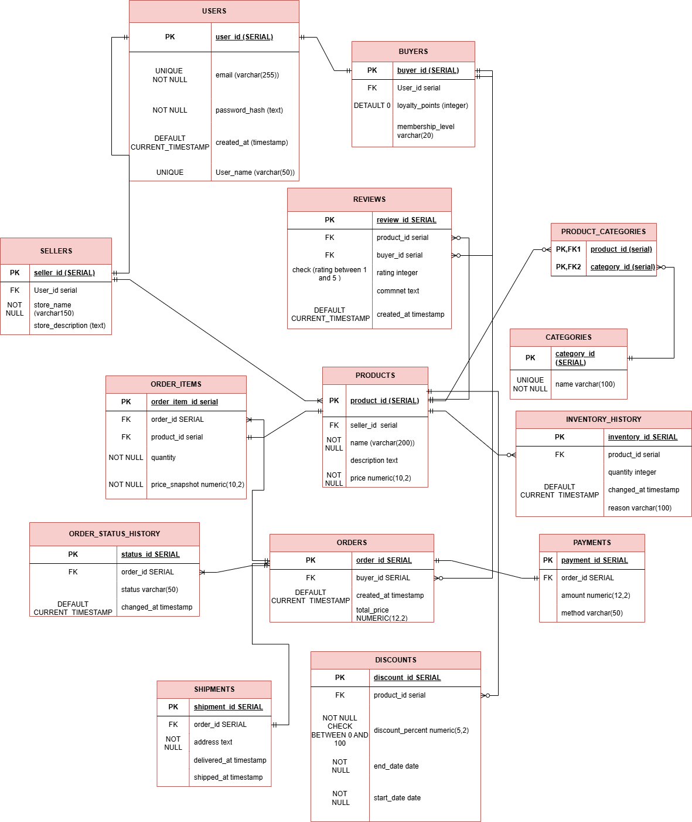

Answer following questions:
- Which modeling decision was the most difficult and why?
- Provide examples of potential data anomalies that your design prevents. Explain which constraints or structure elements prevent them.
- If you were to add new attributes or participants, would the model remain scalable and why?
- Which part of your model would most likely change if requirements expand?
One of the most challenging modeling decisions was separating the users, buyers, and seller tables. This approach allows one user to have different roles in the system without duplicating personal data.
The design prevents several data anomalies. For example, foreign key constraints ensure that orders cannot exist without a valid buyer and products cannot exist without seller. The many-to-many relationship between products and categories is implemented through the product_categories table, which prevents data duplication.
The model is scalable because entities are separated into independent tables following normalization principles. This structure allows new features, such as additional is implemented through the product_categories table, which prevents data duplication.

The model is scalable because entities are separated into independent tables following normalization principles. This structure allows new features, such as additional payment methods or shipment tracking, to be added without major changes to the existing schema.

If system requirements expand, the parts most likely to evolve are the orders, payments, and shipment management

Objects
Table Description:
- What real-world concept or event does this table represent?
- Why must this information be stored separately instead of inside another table?
- What is the normalization level of the table (1NF, 2NF, 3NF)? Explain your reasoning.
- Are there partial or transitive dependencies? How did you eliminate them? Which attributes depend only on the key, and which depend on other fields?
- Why did you choose this primary key (PK) for the table? Could a composite key work instead? Which foreign keys (FK) did you add and why?
- Table Name | Field name | Field Description | Data Type
Table 1 | Field Name 1 | <description>, PK/FK | Int
 | Filed Name N | <description> | Text

Field Name 1 | Field name 2 | Field name 3 | Field name N
1 | aaa | 123 | 1234

USERS
The users table represents all accounts registered in the marketplace platform. It stores general information about people using the system. This data is stored separately so that both buyers and sellers can share the same base account without duplicating personal information. The table satisfies 3NF because all attributes depend only on the primary key user_id.

Table Name | Field name | Field Description | Data Type
USERS | User_id | PK – unique identifier for each user | SERIAL
 | email | User’s email address for login and communication | varchar(255)
 | Password_hash | Hashed password for authentication | Varchar(255)
 | Created_at | Timestamp when user registered | timestamp

User_id | email | Password_hash | Created_at
1 | nona@gmail.com | hash123… | 2024-01-15 10:30:00
2 | ana@gmail.com | Hash234… | 2024-02-20 09:15:00
3 | bob@gmail.com | Hash256… | 2024-03-01 11:00:00

BUYERS

The buyers table represents users who purchase products on the platform. It extends the users table by identifying which users act as buyers in the marketplace. This information is stored separately to support role management without duplicating user data. The table is in 3NF because all attributes depend only on the primary key buyer_id.
Example with data (2-3 rows)

Table Name | Field name | Field Description | Data Type
BUYERS | buyer_id | Unique identifier for buyer (references users) PK | SERIAL
 | loyalty_points | Points accumulated from purchases | INTEGER
 | membership_level | Buyer’s membership tier | Varchar(20)
 | User_id | FK | serial

Buyer_id | Loyalty_points | Membership_level
1 | 1500 | gold
2 | 750 | silver
3 | 0 | bronze

SELLERS
The sellers table represents users who sell products in the marketplace. Each seller is linked to a user account. Separating sellers from users allows the system to support multiple roles for a single user while maintaining clear relationships between sellers and products. The table satisfies 3NF since all attributes depend only on the primary key seller_id.
Table Name | Field name | Field Description | Data Type
SELLERS | seller_id | PK , – unique identifier for each user | SERIAL
 | Store_name | Name of the seller's store | varchar(150)
 | store_description | Detailed description of the store | TEXT
 | joined_date | Date when seller joined the platform | DATE
 | User_id | FK | SERIAL

Selller_id | Store_name | Store_description | Joined_at
1 | Tech Haven | Electronics and gadgets store | 2024-01-15 10:30:00
2 | Fashion Hub | Trendy clothing and accessories | 2024-02-20 09:15:00
3 | Bookworm’s paradise | New and used books | 2024-03-01 11:00:00

PRODUCTS
The products table represents items offered for sale by sellers in the marketplace. Each product belongs to a single seller and can be associated with multiple categories. This table is stored separately because product information is independent from orders and categories. The table is normalized to 3NF, as all attributes depend only on the primary key product_id.

Table Name | Field name | Field Description | Data Type
PRODUCTS | Product_id | PK – unique identifier for each user | SERIAL
 | Seller_id | References the seller who offers this product | serial
 | name | Product_name | Varchar(200)
 | price | Current selling price | Numeric(10,2)

product_id | Seller_id | name | price
1 | 4 | iPhone 13 | 999.99
2 | 4 | MacBook Pro | 1999.99
3 | 5 | Summer Dress | 49.99

CATEGORIES
The categories table represents product classifications used to organize items in the marketplace. Categories help users find products more easily by grouping them into logical sections. This information is stored separately to avoid repeating category names in multiple product records. The table satisfies 3NF because all attributes depend only on the primary key category_id
Table Name | Field name | Field Description | Data Type
CATEGORIES | Category_id | Unique identifier for product category  (PK) | serial
 | name | Category name | Varchar(100)

product_id | Seller_id
1 | Electronics
2 | Smartphones
3 | Laptops

PRODUCT_CATEGORIES
The product_categories table implements the many-to-many relationship between products and categories. A product may belong to multiple categories, and a category may contain multiple products. This table exists to avoid data duplication and maintain normalized relationships between the two entities. The table is in 3NF because each attribute depends only on the composite key (product_id, category_id).
Table Name | Field name | Field Description | Data Type
PRODUCTS_CATEGORIES | Category_id | References category  Fk/pk | serial
 | Product_id | References the product pk/fk | serial

product_id | Category_id
1 | 3
2 | 4
3 | 2

ORDERS
The orders table represents purchase transactions created by buyers. Each order belongs to a specific buyer and may include multiple products through the order_items table. Storing orders separately allows the system to manage transactions independently from product data. The table satisfies 3NF, as all attributes depend only on the primary key order_id.
Table Name | Field name | Field Description | Data Type
ORDERS | order_id | PK – unique identifier for each user | SERIAL
 | buyer_id | References the buyer who placed the order | serial
 | created_at | Timestamp when order was created | TIMESTAMP
 | total_price | Total amount for the order | Numeric(12,2)

order_id | Buyer_id | Created_at | Total_price
1 | 4 | 2024-03-05 14:30:00 | 999.99
2 | 4 | 2024-03-04 14:30:00 | 1999.99
3 | 5 | 2024-03-05 14:30:00 | 49.99

ORDER_ITEMS
The order_items table represents individual products included in an order. It links orders with products and stores information such as quantity and price at the moment of purchase. This table is necessary to support orders containing multiple products. The structure satisfies 3NF because all attributes depend on the primary key and the relationship between order and product.
Table Name | Field name | Field Description | Data Type
ORDER_ITEM | order_item_id | PK – unique identifier for each user | SERIAL
 | order_id | References the order that contains this item FK | serial
 | product_id | References the product being ordered FK | serial
 | quantity | Number of units ordered | integer
 | price_snapshot | Price of the product at the time of order | NUMERIC(10,2)

product_id | Seller_id | name | price
1 | 4 | iPhone 13 | 999.99
2 | 4 | MacBook Pro | 1999.99
3 | 5 | Summer Dress | 49.99

PAYMENTS
The payments table records financial transactions associated with orders. It stores information about how and when a buyer paid for an order. Payments are stored separately to support different payment methods and possible multiple transactions per order. The table satisfies 3NF because all attributes depend only on the primary key payment_id.
Table Name | Field name | Field Description | Data Type
PAYMENTS | payment_id | PK – unique identifier for each user | SERIAL
 | order_id | References the order that contains this item FK | serial
 | amount | References the product being ordered FK | serial
 | method | Number of units ordered | integer

Payment_id | Order_id | amount | method
1 | 4 | 999.99 | Credit Card
2 | 4 | 125.50 | PayPal
3 | 5 | 1000.00 | Credit Card

SHIPMENTS
The shipments table represents the delivery process of orders to buyers. Each shipment is associated with a specific order and contains delivery-related information. This table is separated from orders to support cases where an order may have multiple shipments. The table is in 3NF because all attributes depend only on the primary key shipment_id.

Table Name | Field name | Field Description | Data Type
SHIPMENTS | shipment_id | PK – unique identifier for each user | SERIAL
 | order_id | References the order that contains this item FK | serial
 | address | Shipping destination address | TEXT
 | shipped_at | Timestamp when order was shipped | TIMESTAMP
 | delivered_at | Timestamp when order was delivered | TIMESTAMP

shipment_id | order_id | address | Shipped_at
1 | 4 | 123 Main St, City, ST 12345 | 2024-03-06 10:00:00
2 | 4 | 456 Oak Ave, Town, ST 6789 | NULL
3 | 5 | 123 Main St, City, ST 12345 | 2024-03-06 10:00:00

REVIEWS
The reviews table stores feedback provided by buyers about products they have purchased. Reviews typically include ratings and comments that help other users evaluate products. This information is stored separately from products to allow multiple reviews per product. The table satisfies 3NF since all attributes depend only on the primary key review_id.

Table Name | Field name | Field Description | Data Type
REVIEWS | review_id | PK – unique identifier for each user | SERIAL
 | product_id | References the product being reviewed | serial
 | buyer_id | References the buyer who wrote the review | SERIAL
 | rating | Numeric rating given to the product | INTEGER
 | comment | Text of the review | TEXT
 | created_at | Timestamp when review was submitted | TIMESTAMP
Review_id | Product_id | Buyer_id | rating | commnet | Created_at
1 | 4 | 1 | 5 | "Excellent phone! Battery life is amazing." | 2024-03-06 15:30:00
2 | 4 | 4 | 4 | "Great phone but a bit expensive" | 2024-03-07 09:45:00
3 | 5 | 6 | 5 | "Love this dress, perfect fit!" | 2024-03-06 15:30:00

INVENTORY_HISTORY
The inventory_history table records all changes in product stock levels. Instead of updating stock values directly in the products table, each change is stored as a separate record. This approach preserves historical data and allows tracking inventory changes over time. The table is normalized to 3NF because all attributes depend only on the primary key inventory_id.
Table Name | Field name | Field Description | Data Type
INVENTORY_HISTORY | inventory_id | PK – unique identifier for each user | SERIAL
 | product_id | References the product whose inventory changed | serial
 | quantity | Shipping destination address | integer
 | shipped_at | Quantity change (positive for addition, negative for reduction) | integer
 | changed_at | Timestamp when inventory change occurred | TIMESTAMP
 | reason | Reason for inventory change | VARCHAR(100)

inventory_id | product_id | Changed_at | reason | quantity
1 | 4 | 2024-03-01 09:00:00 | Initial stock | 50
2 | 4 | 2024-03-01 09:00:00 | Order #3 | 20
3 | 5 | 2024-03-01 09:00:00 | Initial stock | -1

(I apologize for last 2 tables I didn’t have time)

